ACT 3
Hypothesis testing
“Passengers tip more during late-night trips because of better service / driver behavior.”
Define late night: 10 PM – 4 AM
Define metric: tip_percentage = tip_amount / fare_amount
So the hypothesis becomes:
Mean tip_percentage (late night) > Mean tip_percentage (daytime)
H0​:μnight​=μday​,H1​:μnight​>μday​
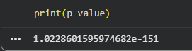

Alternate:
Night tips depend on the type of ride. So the shorter ride gets less tip compared to the longer rider during the night.
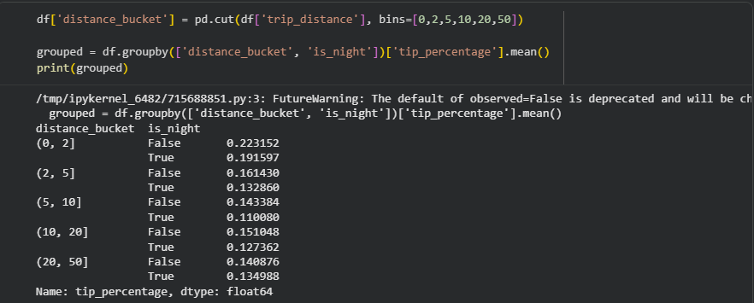
Here are the stats, which show the percentage of tipping higher.
But even during night it not very likely to tip high as the conditions of the passengers also depend (drunk, rude, etc)

H0: It is very much assumed and happens a lot
But alternate is not very likely, but it is possible to occur in such cases.
My conclusion would change if we very much consider the trip, location, time, policy, type of payment, and the surge of price.

ACT 4
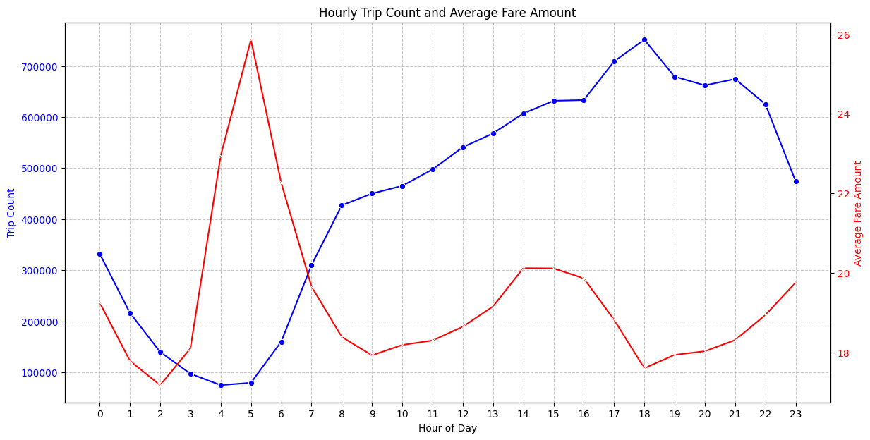
So a persisting pattern on hour vs trip. There is a low trip count at midnight but gradually increases, but the fare is opposite of it. And this pattern occurs a lot.

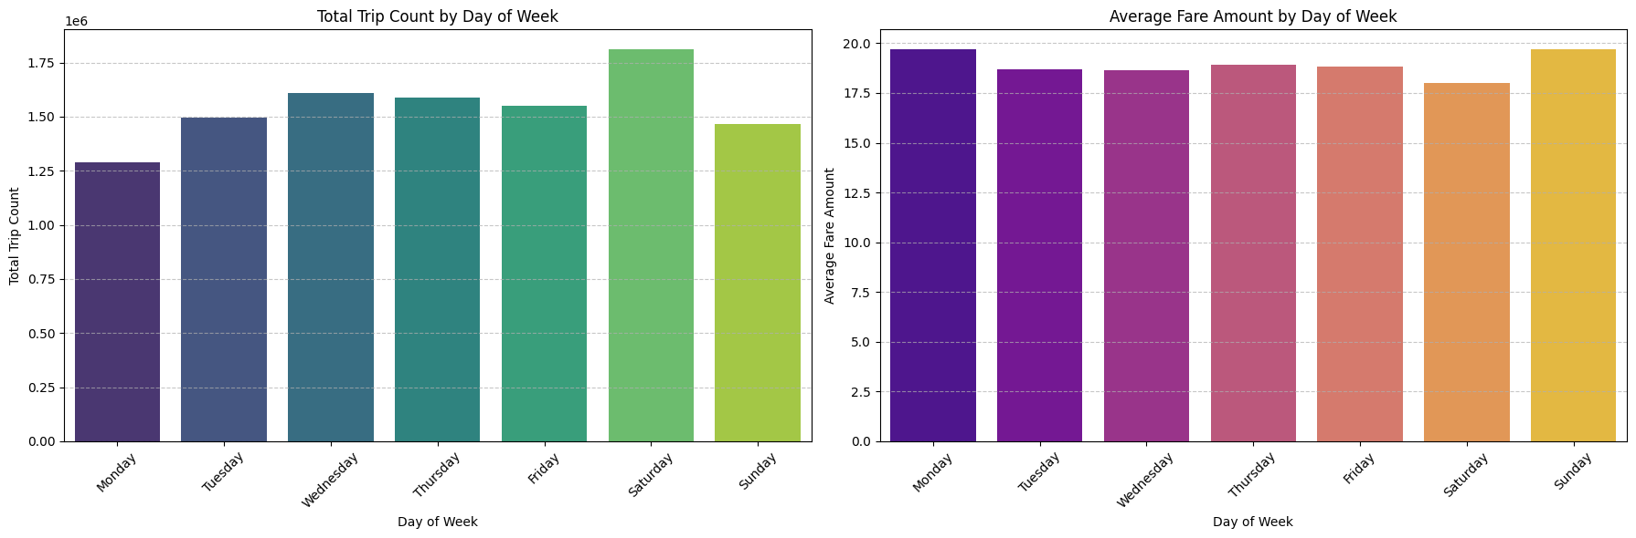
Along with the hour vs trip count. Also the weekly pattern persist again and again. As most of the passengers travel alot during the weekend.
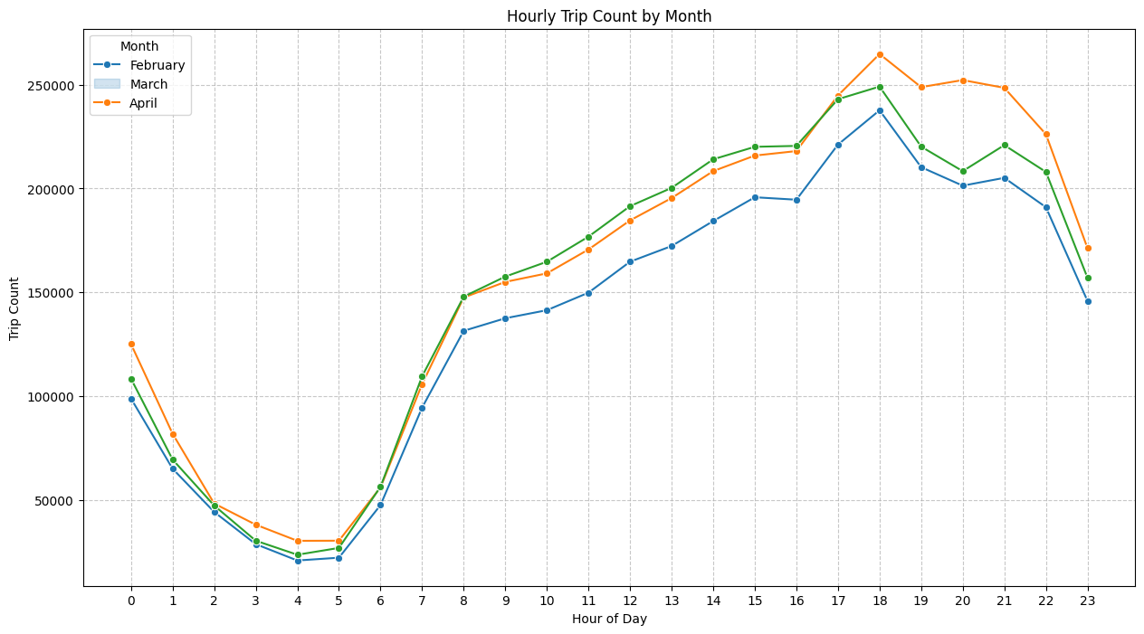
The trend across the 3 months are almost the same so there are no unusual trends to begin with.
The disappearing patterns might be a change in the hourly pattern as this data is only on the month of feb, mar, april. As seasons change even the trip count changes.

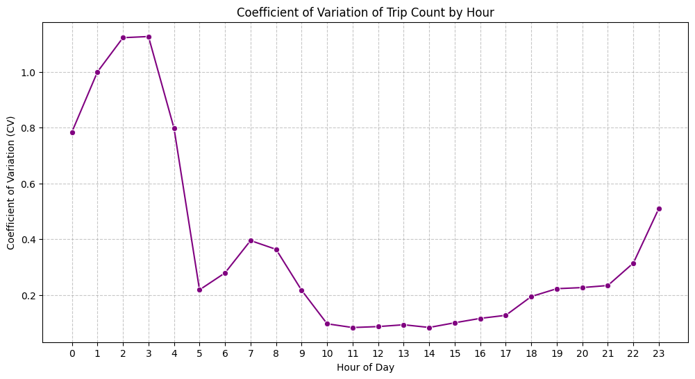
So after seeing the graph we can conclude that there is a stable pattern during 9 - 21. And a noise from 0 - 8 and 22 - 23.

ACT 5

Policy lever chosen
Increase base fare by +15% during peak hours (7–10 AM, 5–9 PM)

Why this parameter?
- Directly affects demand (passengers)
- Indirectly affects supply (drivers choose when to work)
- Already aligned with real-world mechanisms (surge pricing logic)
This is not random—it’s a high-leverage control variable.

Step 1 — Define the simulation (don’t hand-wave)
You need to simulate:
- New fare = fare_amount * 1.15 (only peak hours)
Typical urban transport elasticity:
-0.2 to -0.5
for +15%:
- Expected demand drop ≈ 3% to 7%
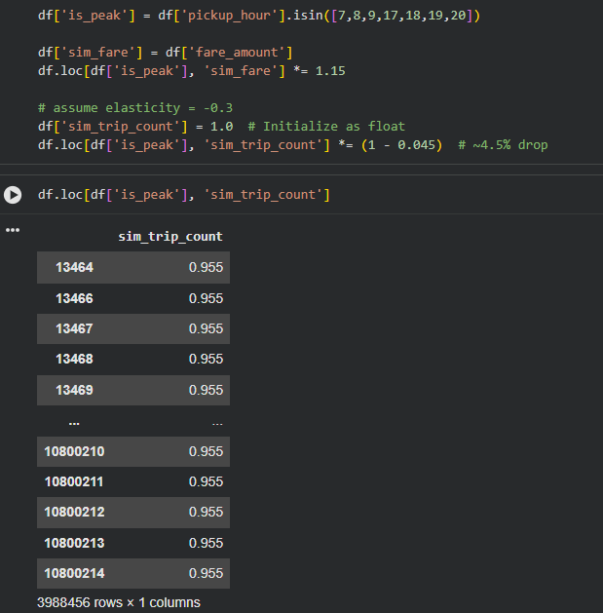

As seen, demand drops a bit but still the fare can be increased. The system partially absorbs the change.
It amplifies, as more fare implies more divers come to work, reduce the waiting time of the passengers, and supply increases.
It might respond unexpectedly, as due to more fare passengers may chose different transport option. So the peak time might reduce and have a stable curve all the time.
So revenue can ben increased but the demand may drop, and would result in less trips in peak hours

